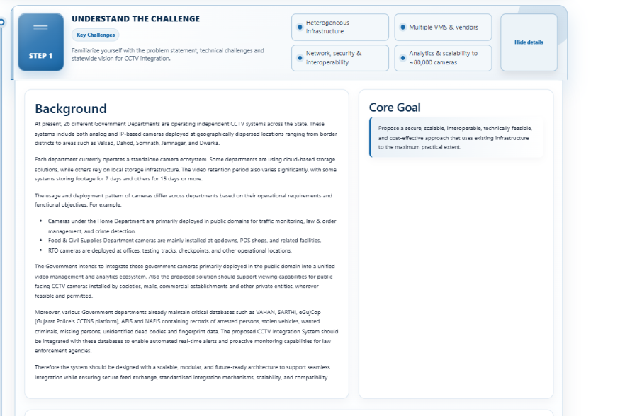
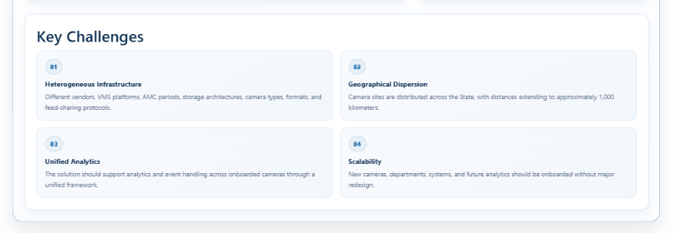
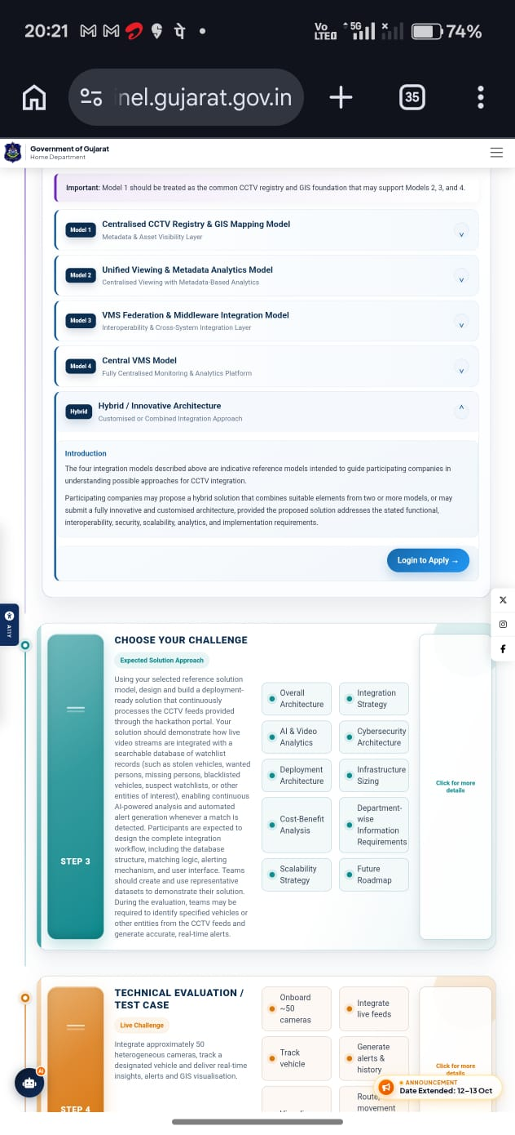
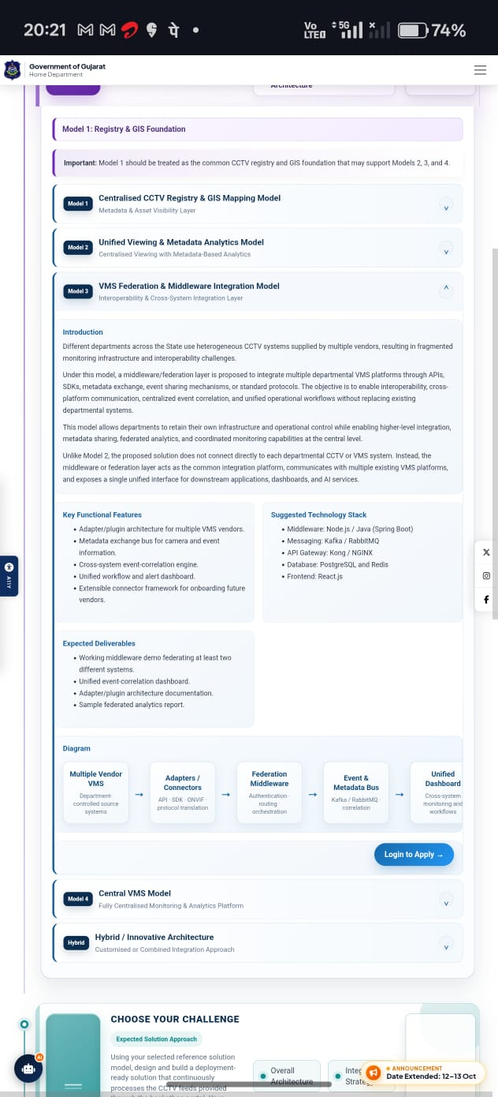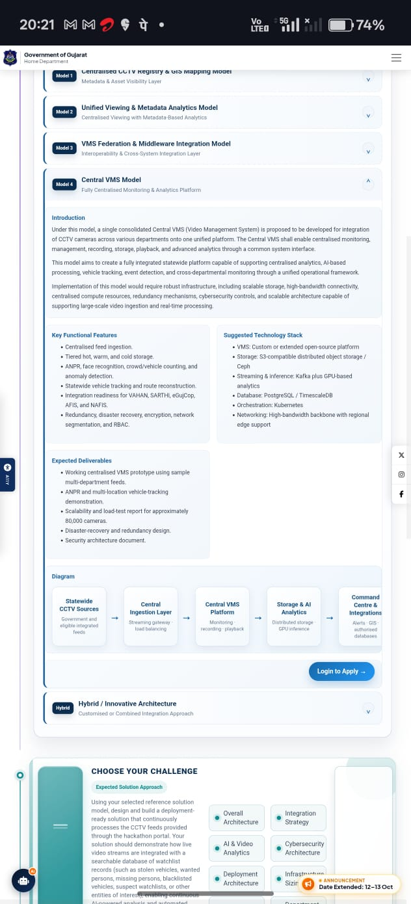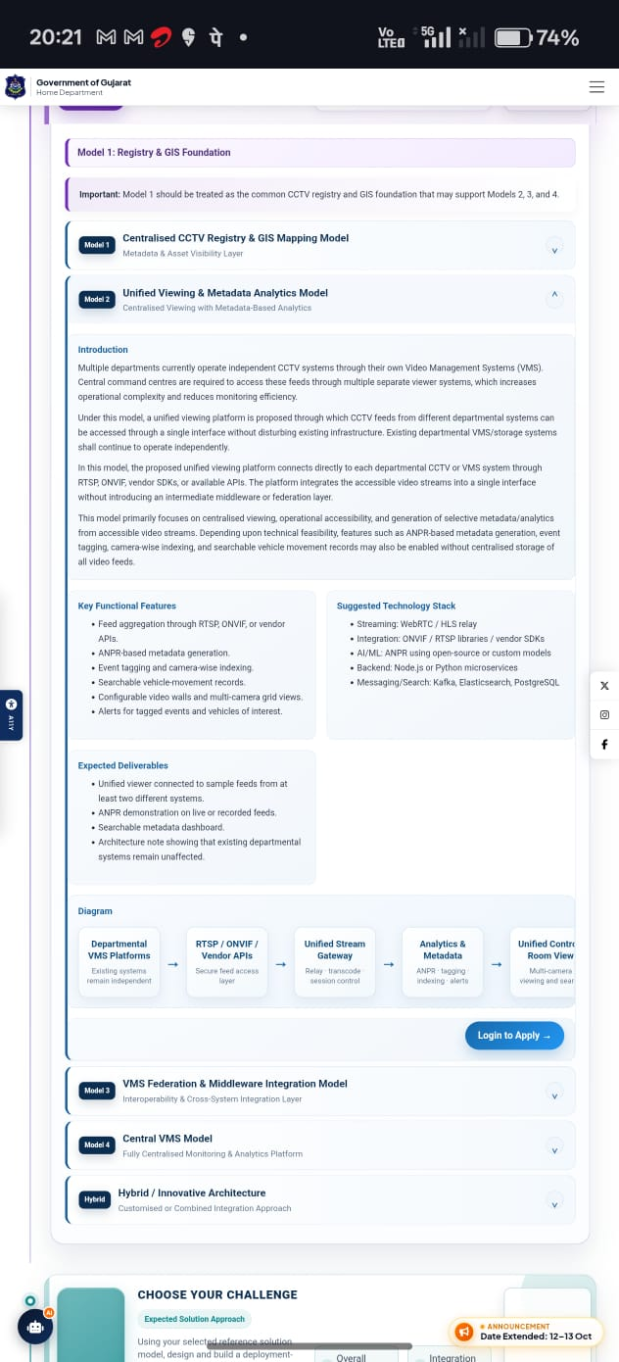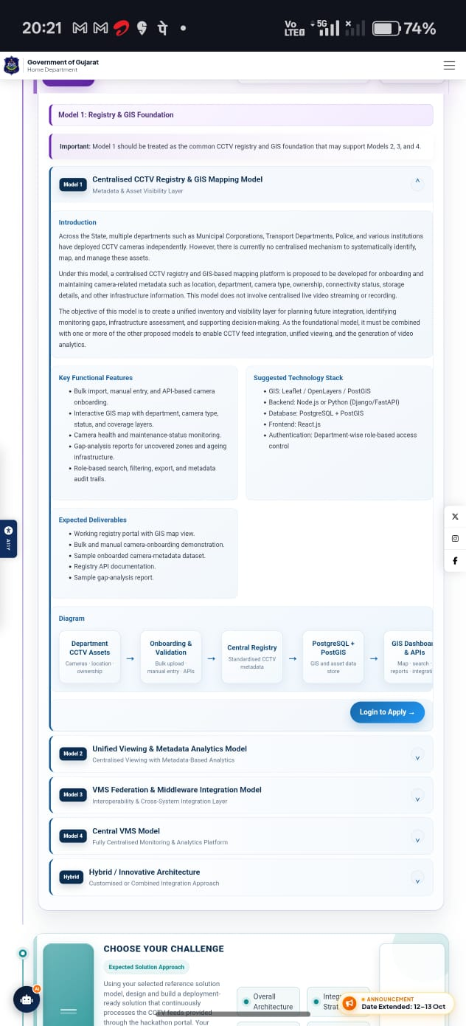

OUR PIPELINE:
[ 80,000+ HETEROGENEOUS CAMERAS ]
(Public, RTO, Police, Food & Civil)
│
▼
┌────────────────────────────────────────────────────────────────────────────────────────────────────────┐
│ MODEL 3: VMS FEDERATION & MIDDLEWARE LAYER │
│ Analog DVRs / IP Cameras ──► Custom Adapters ──► RTSP / ONVIF ──► MediaMTX (Stream Gateway) │
└──────────────────────────────────────────────────┬─────────────────────────────────────────────────────┘
│
▼
┌────────────────────────────────────────────────────────────────────────────────────────────────────────┐
│ MODEL 2: REGIONAL EDGE AI LAYER │
│ Local DVR Storage (7-15 Days) │ Frame Sampling (5-10 FPS) ──► YOLOv8-Nano (Detection) │
│ │ │ (Vehicle/Person Detected?) │
│ │ ▼ │
│ │ ByteTrack (Deduplication) │
│ │ │ │
│ │ ┌──────────┴──────────┐ │
│ │ ▼ ▼ │
│ │ ALPR Engine Face Pipeline │
│ │ └──────────┬──────────┘ │
│ │ ▼ │
│ │ Confidence Gate (>0.85) │
└────────────────────────────────┴──────────────────────────────────┬────────────────────────────────────┘
│ (JSON Metadata Payload)
▼
┌────────────────────────────────────────────────────────────────────────────────────────────────────────┐
│ MODEL 4: CENTRAL EVENT BUS & INTEGRATION LAYER │
│ Apache Kafka Message Bus (`vehicle-detections` / `watchlist-matches`) │
│ │ │
│ ▼ │
│ In-Memory Redis Watchlist Cache (Sub-millisecond Lookup) │
│ │ (Match Found?) │
│ ▼ │
│ Asynchronous API Webhooks ──► External Government DBs (VAHAN / SARTHI / eGujCop / NAFIS) │
│ │ │
│ ▼ │
│ SHA-256 Hashing ──► Central Cold Evidence Vault & Audit Logging │
└───────────────────────────────────┬────────────────────────────────────────────────────────────────────┘
│ (WebSocket Real-Time Event Push)
▼
┌────────────────────────────────────────────────────────────────────────────────────────────────────────┐
│ MODEL 1: CENTRAL GIS COMMAND DASHBOARD │
│ React.js + Leaflet / PostGIS Map │
│ ├── 🚨 Real-time Visual Alert on Camera Coordinates │
│ ├── 🛣️ Vehicle Route Reconstruction Polyline │
│ └── 📹 On-Demand WebRTC Video Stream Player (Establishes direct relay to Regional Edge) │
└────────────────────────────────────────────────────────────────────────────────────────────────────────┘
Final Tech Stack Matrix
Domain | Selected Technology | Operational Role
Ingestion & Relay | MediaMTX (Go) + FFmpeg | Converts raw RTSP/ONVIF camera streams into WebRTC/HLS for low-latency web playback.
Edge Computer Vision | YOLOv8-Nano + ByteTrack | Low-latency object detection and cross-frame object tracking/deduplication.
Text & Face OCR | Fast-Plate-OCR / InsightFace | License plate character extraction and facial feature vector embedding.
Inference Runtime | ONNX Runtime / TensorRT | Quantized model acceleration for edge CPU/GPU execution.
Event Bus | Apache Kafka | Distributed message broker buffering high-concurrency event telemetry.
Caching Layer | Redis Cluster | In-memory store housing active watchlists for sub-millisecond matching.
Core Database | PostgreSQL + PostGIS | Geographic spatial index, camera asset registry, and time-series detection logs.
Backend API | FastAPI (Python) | High-concurrency REST endpoints and WebSockets for real-time dashboard updates.
Frontend UI | React.js (Vite) + Leaflet | Command center GIS mapping, camera health monitoring, and video wall playback.

• Phase 1: GIS & Asset Foundation
- Deploy PostgreSQL + PostGIS container.
- Seed 50 simulated camera assets with coordinates, department ownership, and status.
- Build the React + Leaflet map interface rendering color-coded camera markers.
• Phase 2: Media Federation Layer
- Set up MediaMTX.
- Use FFmpeg to generate 50 distinct RTSP streams from sample traffic videos.
- Connect React dashboard to MediaMTX via WebRTC, enabling live viewing upon clicking map nodes.
• Phase 3: Cascaded Edge AI
- Build the Python frame-sampling pipeline (YOLOv8-Nano $→$ ByteTrack $→$ ALPR).
- Generate JSON event metadata payloads containing plate string, confidence score, camera ID, and timestamp.
• Phase 4: Intelligence Pipeline & Matching
- Configure Kafka topics (vehicle-detections, watchlist-matches).
- Populate Redis with mock VAHAN stolen vehicle watchlists.
- Trigger real-time WebSocket alerts on the GIS map when an ALPR detection matches a Redis entry.
• Phase 5: Forensic Investigation Features
- Build the "Vehicle Route Reconstruction" feature: search a license plate to draw sequential polyline tracks across camera locations on the GIS map.
- Implement SHA-256 hashing mock for video evidence verification.
• Phase 6: Presentation & Metrics Polish
- Add system health widgets (Camera Status: Online/Degraded/Offline, Bandwidth Saved %, Inference Latency).
- Rehearse the final end-to-end presentation story.
second approach
The Definitive Hybrid Edge-Cloud Pipeline
This is the exact data and execution path you will build and present. It is designed to run 50 live heterogeneous cameras without race conditions, CPU bottlenecks, or synchronous deadlocks.
I. The Edge Boundary (Regional Processing)
1. Stream Normalization Layer
- Input: 50 diverse video feeds (Legacy Analog DVRs via encoders, IP Cameras via RTSP/ONVIF).
- Execution: Incoming feeds are routed through MediaMTX.
- Memory Management: Use C++ wrappers for the feed ingestion to handle dynamic memory allocation and pointer discipline natively. If an RTSP packet is corrupted, the C++ daemon flushes the buffer and grabs the next frame instantly without crashing the pipeline.
- Output: Standardized low-latency WebRTC streams held at the regional level, ready for on-demand pulling.
2. Cascaded AI Inference Layer
- Frame Sampling: Extract frames at 5–10 FPS (not 30 FPS) to preserve compute.
- Stage A (Detection): YOLOv8-Nano scans the frame. If no vehicle is present, the frame is dropped immediately.
- Stage B (Tracking): ByteTrack assigns a unique ID to the detected vehicle. This prevents the system from scanning the same parked car 50 times a second.
- Stage C (Extraction): The cropped bounding box is passed to EasyOCR/Fast-Plate-OCR to extract the alphanumeric string.
- Output: A structured JSON metadata payload ($≈2$ KB): {"plate": "GJ01AB1234", "cam_id": "CAM_42", "lat": 23.02, "lon": 72.57, "timestamp": "..."}.
II. The Transit Layer (Network Optimization)
3. The Asynchronous Event Bus
- Execution: The JSON payload is published to Apache Kafka (or Redis Pub/Sub for hackathon speed).
- Why it wins: The heavy 4K video frame is destroyed at the edge. Only the 2 KB JSON string crosses the state network. This guarantees the central cloud is never bottlenecked by ingestion limits, satisfying the requirement for end-to-end system performance.
III. The Central Cloud (Intelligence & Routing)
4. The Verification & Logging Engine
- Worker Pool: Python backend workers consume the Kafka events asynchronously. This avoids CPU scheduling deadlocks; the pipeline never waits for a database to respond.
- Watchlist Verification: The Python worker queries a Redis in-memory cache populated with mock VAHAN/eGujCop data. Matches are confirmed in sub-milliseconds.
- Time-Series Logging: Every detected plate (match or not) is written to a PostgreSQL (TimescaleDB) database. Applying strict relational normalization here ensures that concurrent writes from 50 cameras do not cause database table locks.
IV. The Command Center (Frontend Dispatch)
5. Real-Time GIS UI
- Alert Push: When a watchlist match occurs, the Python backend fires a payload over WebSockets directly to the React frontend.
- Map Visualization: The React app, using Leaflet and PostGIS spatial coordinates, instantly renders a flashing red alert on the specific camera node.
- Route Reconstruction: When judges ask to trace a specific vehicle, the operator inputs the license plate. The UI queries the PostgreSQL database, retrieves the normalized time-series logs, and draws a sequential polyline across the map using the historical coordinates.
- On-Demand Video: The operator clicks the flashing map node, which establishes a direct WebRTC peer connection back to the regional MediaMTX server, displaying the live video feed instantly without taxing the central server.

